Climate Action Plan
Spring 1 2026
Action | Cost | Timeframe | Target | Responsible | Development plan | Progress  (if applicable) | Complete
10/01/2026  Create a sustainability policy | 0 | ½ day | To have a policy in place to share with team/ caregivers | Nat / Jen | Send to team and caregivers | Review annually
13/01/2026  Use staff meeting to introduce sustainability and climate action power point.  (Whole-setting approach) | 0 | 4 weeks | Team ideas on how we can start to be sustainable. | Nat | Create a to do list
15/01/2026  Carbon footprint audit | 0 | 2 weeks | To estimate our footprint | Nat + Room leaders | How can we reduce?
16/01/2026  Start to look at small changes we can make to get us started. | 0 | 6 weeks / Half term | Getting the team into the climate action approach | All
14/01/2026  Staff training from TTS talking and google form questionnaire | 0 | Full term  (12 weeks) | Embedding the knowledge into the team | All
13/01/2026  Make a list of resources for outdoors | TBC | 6 weeks | Edging to the greater sustainable goal. | Nat | Cutting our carbon footprint

Staff ideas from meeting on 13/01/2026
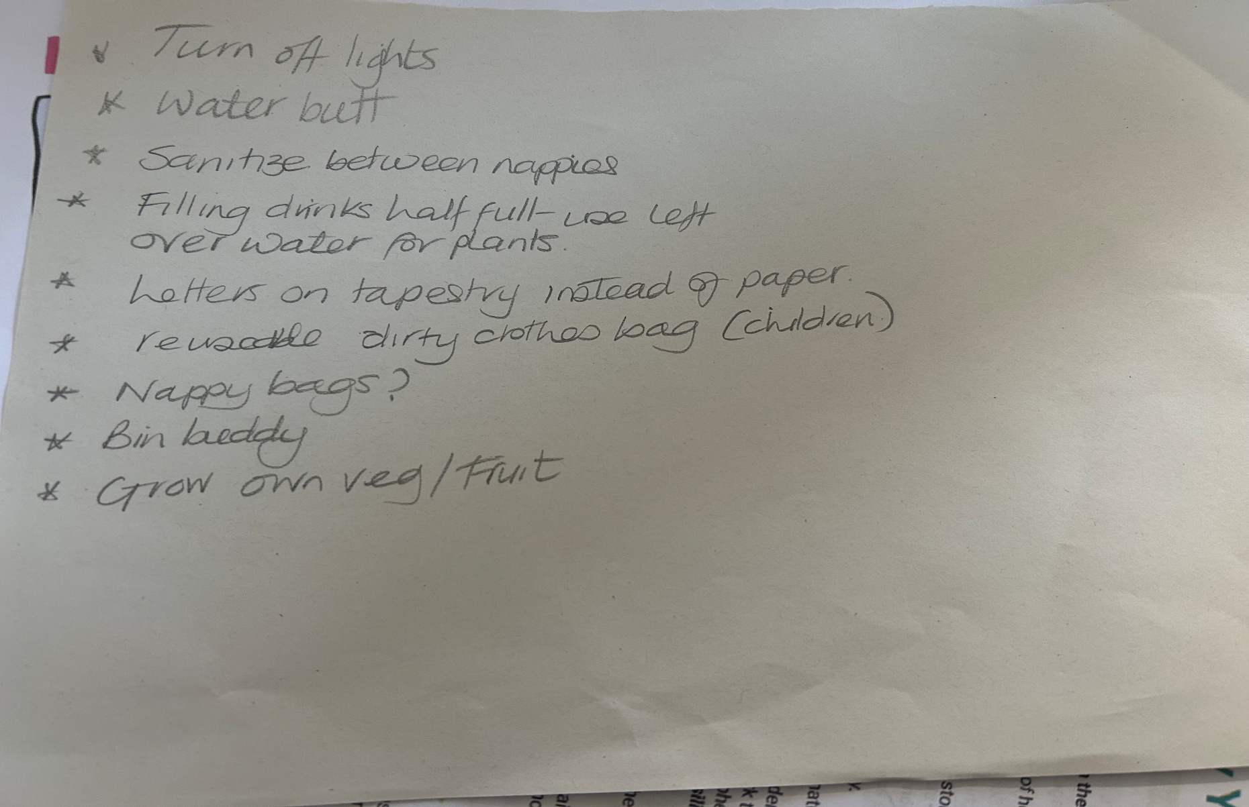

Staff training
https://worldofeducation.tts-group.co.uk/episode-13-recycling-and-reusing-in-the-early-years/
(episode 13,14,15,16) followed by questionnaire on google forms

Changes we had already put into place
Change from: | Changed to: | Successfully changed
Disposable cloths/ blue roll for wiping tables/toys | Reuseable microfiber cloth
Disposable paper towels for children to dry hands | Reuseable microfiber cloth cut into smaller pieces
Children’s bedding being washed after every use | Washed once a week (unless needed more due to being soiled)

Small changes to be put in place
Change from: | Changed to: | Successfully changed
Lights being on all day | Turn off when not in the room
Washing hands after every nappy | Sanitise in between and wash with soap and water when complete
Children’s drinking bottles | Half fill – and refill when needed/ after lunch, use left over to water the plants
Pre-School water keg | Half fill – and refill when needed, use left over to water the plants
Letters home to parents/carers | Send via tapestry or email to cut down paper waste
Disposable nappy sacks for dirty clothes | Purchase reuseable waterproof bags/ to be brought back when used
Disposable nappy sacks for dirty nappies | Research into a bin buddy to cut down plastic waste
Bought fruit and vegetables from the supermarket | Research and implement growing own potatoes, strawberries, cucumbers, herbs, carrots and tomatoes to get us started.
Water from the outside tape for water play etc | Install a water butt to catch the rainwater for play/plants etc

